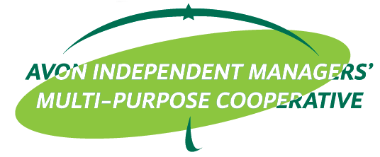

ACTIVITY DESIGN

ACTIVITY : Virtual Meeting
LOCATION : Avon ______
DATE/TIME : _____________

OBJECTIVES:
  - To refresh and update AIM-MPC members to new policies
  - To adopt to the new normal means of training members

PARTICIPANTS:
- ___________________________________

TRAINER/S:
- ___________________________________

BUDGETARY REQUIREMENTS:

Particulars | Budget
Meal for Attendees: P150.00 x ___ pax
Host Allowance (Wifi and Food @P250.00 x 2pax)
Attendees Wifi/Data Allowance P100.00 x ___ pax
Trainer’s and BC meal: P150.00 x 2pax
Trainer’s Fee (P2,500.00)
BC Fee (P1,000.00)
Contingency
TOTAL

Prepared by: Recommending Approval:

________________ EDNA B. CARREON
EdCom Trainer EdCom Chairperson
Approved by: Noted by:

__________________ MILDRED C. BAMBICO
General Treasurer BOD Chairperson

